Body builder
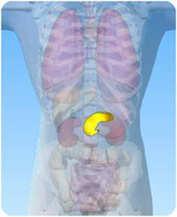

- On the diagram of the digestive system above, what is the name of the circled organ?

- Unscramble the jumbled up words and use them to complete the sentences about the pancreas:
1) The pancreas produces digestive _____________

2) _____________ is also produced by the pancreas.

3) The pancreas is found in the _____________

4) Pancreatic juice is produced by the _____________

5) Pancreatic juice enters the _____________ intestine.

6) Problems with the pancreas can result in ____________

7) Insulin helps to control _____________ in the blood.

8) Enzymes produced by the pancreas help _____________
syzemen
lunnisi
obmaned
scarpean
slaml
estabide
grasu
distoeing

