Body Builder

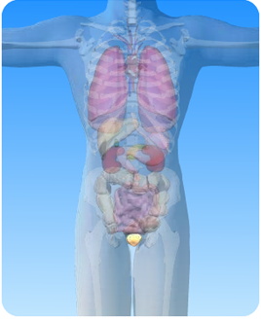
On the diagram of the excretory system above, what is the name of the circled organ?
_______________________________________________

Use the correct word from the list below to complete each sentence about the bladder.

ureters yellow urine bladder close urethra

1) The bladder stores ………….……….

2) The …….………… is part of the excretory system.

3) The bladder is connected to the kidneys by the ……………………

4) Urine is a pale …………..…….. colour.

5) Urine leaves the bladder by the …………….………..

6) In females the urethra opens ………………..…….. to the vagina

