Body Builder
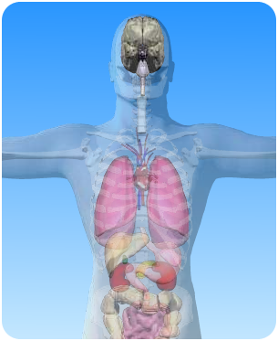
a) On the diagram of the skeleton nervous system, what is the name of the circled part?

b) Read the statements about the brain in the boxes above. Write the statements in the correct columns below:

In an intelligent person the brain is bigger

It is part of the central nervous system

It is connected to the spinal cord
It has a smooth surface

It is protected by the skull
Correct

----------------------------------------------------------------------------------------------------------------------------------------------------------------------------------------------------------------------------------------------------------------------------------------------------------------------------------------------------------------------------------------------------------------------------------------------
Incorrect

----------------------------------------------------------------------------------------------------------------------------------------------------------------------------------------------------------------------------------------------------------------------------------------------------------------------------------------------------------------------------------------------------------------------------------------------

