Body builder
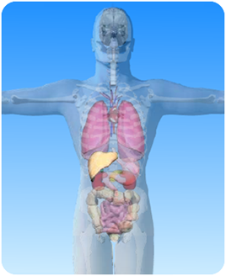
- On the diagram of the digestive system above, what is the name of the circled organ?

- Choose words from the box to fill the blanks in the sentences about the liver:

largest glucose digestion

gall bladder kilogram

bile duct amount diaphragm

The liver is the ……………… organ in the body. It weighs more than one …………….. It is found at the top of the abdominal cavity just under the …………………………….

The ………… ……………………. produces bile which passes down the ………………….. ………………………. into the small intestine. Bile helps in the process of ………………………….

The liver also helps to control the …………………of sugar in the blood by storing any excess ……………………

