Body builder
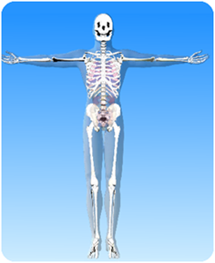

- On the diagram of the skeleton label the following bones and joints:
Collar bone, ribs, skull, backbone, pelvis,
kneecap, thighbone, ankle, elbow and wrist.

- Where in the skeleton is there a ball and socket joint

- Where in the skeleton is there a hinge joint?

- Name two bones (or groups of bones) that are for protection and say what they protect?
Name of bones ____________ What they protect ____________

Name of bones ____________ What they protect ____________

- Name two bones (or group of bones) that are for movement.

Name of bones ____________

Name of bones ____________

