Body builder
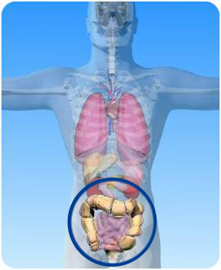
Is connected to the appendix

Joins the mouth with the stomach

Ends at the anus

Where water is absorbed and faeces stored

Makes digestive enzymes

b) Read the statements about the large intestine in the boxes above. Write the statements in the correct columns below:

Contains teeth to grind food

Makes insulin

Correct

------------------------------------------------------------------------------------------------------------------------------------------------------------------------------------------------------------------------------------------------------------------------------------------------------------------------------------------------------------------------------------------------------------------------------------------------------------------
Incorrect

------------------------------------------------------------------------------------------------------------------------------------------------------------------------------------------------------------------------------------------------------------------------------------------------------------------------------------------------------------------------------------------------------------------------------------------------------------------
a) On the diagram of the digestive system to the left, what is the name of the circled organs?

