Body builder
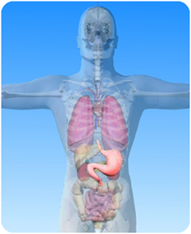

- On the diagram of the digestive system above, what is the name of the circled part?

- Match the words about the stomach from column A with the right definitions from column B and draw a line between them.

Column A | Column B
stomach | helps break down food
gastric juice | food goes here after the stomach
acid | protects the stomach walls
mucus | contains enzymes
3 – 4 hours | is a muscular bag
small intestine | time the food is in the stomach

