Body Builder
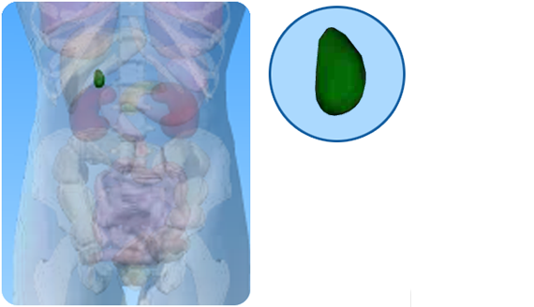

- On the diagram of the digestive system above, what is the name of the circled part?

- Use the correct word from the ‘Word’ box to complete each sentence about the this organ.

liver green bile small

bladder fats stones

- The gall bladder produces _____________
- The gall _____________ is part of the digestive system.
- The gall bladder is found below the _____________
- Bile is a pale _____________ colour.
- Bile enters the _____________ intestine.
- Bile helps the digestion of _____________
- Occasionally gall_____________ are found in the gall bladder.

