Body builder

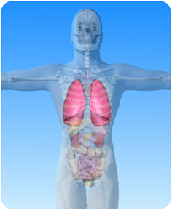

- On the diagram of the respiratory system above, what is the name of the highlighted organs?

- Match the words about the lungs from column A with the right definitions from column B and draw a line between them.
Column A | Column B
lungs | a small branch of a bronchus
ribcage | also known as the trachea
windpipe | takes place in the alveoli
bronchus | have a spongy texture
bronchiole | protects the lungs
Alveolus | tube from the windpipe into one lung
gaseous exchange | tiny sac at the end of a bronchiole

