Body builder

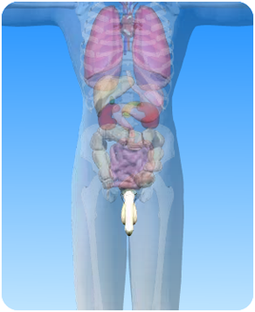

- On the diagram of the male abdominal cavity above, what is the circled part?

- Choose words from the box to fill the blanks in the sentences:

testes penis rapidly

duct epididymis scrotum

swim cooler semen

The ……………… are suspended in the scrotal sac (or ………..) just behind the penis. The testes are positioned outside the main body cavity and are slightly ……………. than the rest of the body. This is important because sperm develop more ………….. in cooler conditions.

Sperm are made in the testes and stored in the coiled ………………..From here they travel through the sperm ………. to the urethra which runs through the centre of the ………….

The prostate gland adds a fluid which helps the sperm to ……….. vigorously. Together with the sperm, this makes ……………

