Body Builder
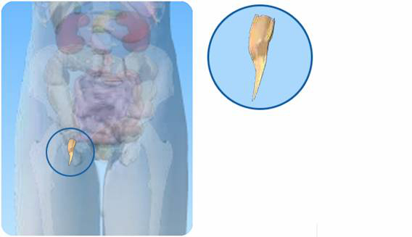

- On the diagram of the digestive system above, what is the name of the circled organ?

- Tick any of the following statements that are true
Appendicitis is an inflammation of the small intestine.
The appendix is used in digestion.
The appendix is attached to the large intestine.
The appendix is the size of your little finger.

c) If you thought some of the statements were not true, write the correct versions:

