Body builder
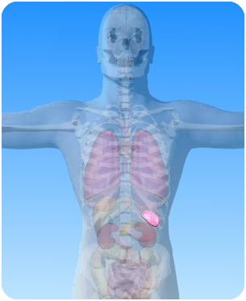

- On the diagram of the abdominal cavity above, what is the name of the circled organ?

- Unscramble the jumbled-up words and use them to complete the sentences about the spleen:
- The spleen is part of the ……………. system

- …….. blood cells are produced by the spleen.

- The spleen is found in the …………………

- It is located just below the ………………….

- Red ……….. cells are destroyed in the spleen.

- Red blood cells usually last about 120 ………

- The spleen is about the size of a ……….

phatlymic
teWhi
obmaned
sady
obold
sfit
phragmiad

