Body builder
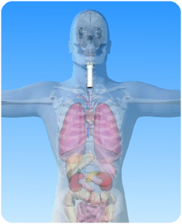

- On the diagram of the body above, what is the name of the circled part?

- Unscramble these sentences about the voice box. Write the correct sentences on the dotted lines.
[Hint: sentences begin with a capital letter and end with a full stop].

- the larynx. is voice box The known as

- to talk. voice box The enables us

- vocal cords The vibrate.

- passes through Air the voice box.

- voice box The trachea. leads to the

- voice box is protected by The cartilage.

