Body builder

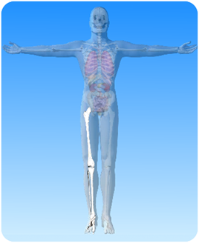

- On the diagram of the skeleton above, what is the name of the highlighted parts?

- Match the words about the leg from column A with the right words from column B and a line between them.
Column A | Column B
femur | one of the leg bones below the knee
patella | one of the leg bones below the knee
ankle | another name for the kneecap
tibia | the longest bone in the leg
ball & socket | the joint between the leg and the foot
fibula | contains lots of small bones
foot | type of joint at the hip

