Body Builder

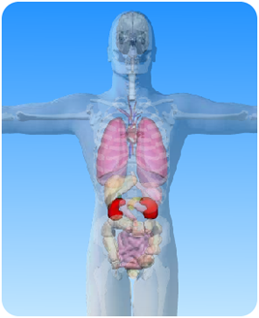

- On the diagram of the body above, what is the name of the circled organs?

b) Unscramble these sentences about the kidneys. Write the correct sentences
on the dotted lines.
[Hint: sentences begin with a capital letter and end with a full stop].
1. two are kidneys. There ________________________
2. are kidneys The bean-shaped. ________________________
3. the system. The kidneys are excretory part of ________________________
4. control water in The kidneys the body ________________________
5. the bladder. goes from Urine to the kidneys ________________________
6. us healthy. Our kidneys keep ________________________

