Body Builder

- What job does the heart do in the body?

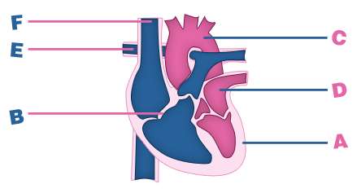

- On the diagram of the heart above label the parts marked A, B, C, D, E and F using the words in the box.

valve thick muscular wall aorta vena cava
pulmonary artery left atrium

- On the diagram of the heart draw arrows to show how blood flows through the heart.

- Put the correct letter (A, B, C, D, E or F) beside each of the following statements:
Statement
Letter
It carries blood to the lungs
It is the wall of the left ventricle
It carries blood into the heart
Blood from the lungs enters the heart
It stops back flow of blood
It is the main artery of the body

