Body builder
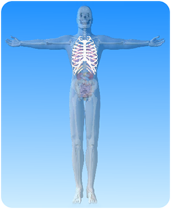

- On the diagram of the skeleton above, what is the name of the highlighted part?

- Choose words from the list to complete the sentences below.

spine muscles pairs out
in protect breastbone

The ribs come in _______________.

The ribs _______________ the heart and lungs.

When breathing in the ribs move _______________.

When breathing out the ribs move _______________.

The ribs are joined to the _______________ at the back.

The ribs are joined to the _______________ at the front.

