Body builder
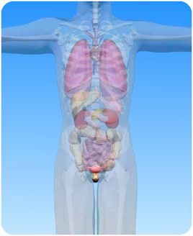

- On the diagram of the female abdominal cavity above, what is the circled part?

- Choose words from the box to fill the blanks in the sentences:

baby womb abdominal

egg fallopian fertilisation

grown ovaries sperm

The female reproductive organs are found in the ……………… cavity. There are two …………….. in which the egg cells develop. Once a month a ripe egg passes down one of the ……………………………. tubes. If ………….. are present, ………………….. of the egg may take place.
The fertilized …… then continues down into the uterus (or ………) where it grows into a ………..
After nine months, when the baby is fully ……………, the baby is born by passing out through the vagina.

