Body builder
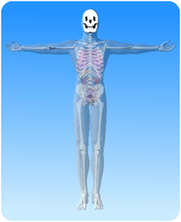

- On the diagram of the skeleton above, what is the name of the highlighted part?

- Match the beginnings about the skull from column A with the endings from column B and draw a line between them.
Column A | Column B
The skull is | the skull joins the spine.
The skull | up and down and sideways.
There are two holes in the skull | skull is the jaw.
The lower part of the | also called the cranium.
At the back | called the eye sockets
The lower jaw moves | protects the brain.

